**Practical 7: Design a webpage to demonstrate the working of a simple stored**

**procedure**.

The webpage will use **ASP.NET Web Forms** and **SQL Server** to retrieve and display user details.

**Steps to Implement:**

1. **Create a Stored Procedure in SQL Server**
2. **Design an ASP.NET Web Form (ASPX Page)**
3. **Connect to the Database and Execute the Stored Procedure**
4. **Display the Results in a GridView**

**1. Create the Stored Procedure in SQL Server**

Run this SQL script in **SQL Server Management Studio (SSMS)**:

CREATE PROCEDURE GetUsers

AS

BEGIN

SELECT Id, Name, Email FROM Users

END

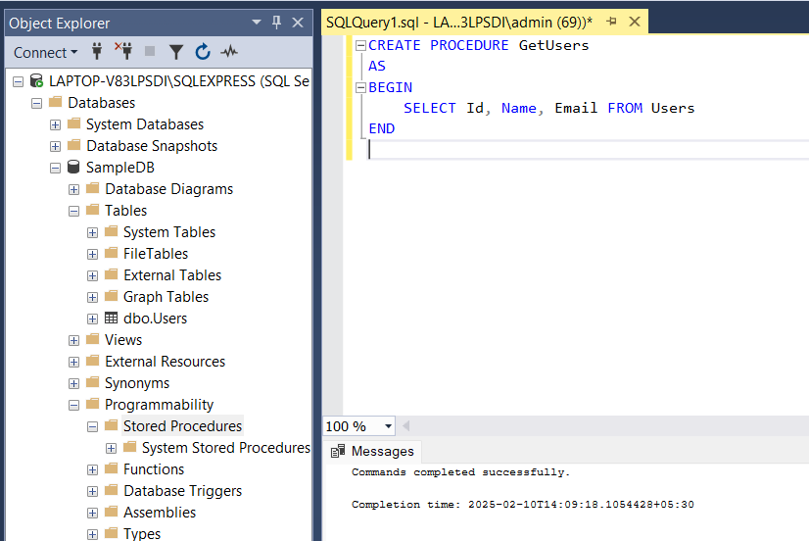

**2. Create an ASP.NET Web Application in Visual Studio**

* Open **Visual Studio**
* Create a new **ASP.NET Web Forms Application**
* Add a **Web Form (Default.aspx)**

**3. Design the Web Form (Default.aspx)**

Modify the WebForm1.aspx file:

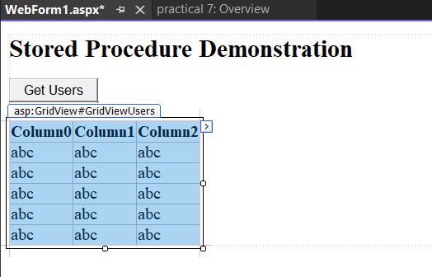

<%@ Page Language="C#" AutoEventWireup="true" CodeBehind="WebForm1.aspx.cs" Inherits="practical_7.WebForm1" %>

<!DOCTYPE html>

<!DOCTYPE html>

<html>

<head>

<title>Stored Procedure Demo</title>

</head>

<body>

<form id="form1" runat="server">

<h2>Stored Procedure Demonstration</h2>

<asp:Button ID="btnGetUsers" runat="server" Text="Get Users" OnClick="btnGetUsers_Click" />

<br /><br />

<asp:GridView ID="GridViewUsers" runat="server" AutoGenerateColumns="true" BorderColor="Black" BorderWidth="1px" />

</form>

</body>

</html>

**4. Code-Behind File (Default.aspx.cs)**

Modify Default.aspx.cs to execute the stored procedure and display results in GridView:

using System;

using System.Configuration;

using System.Data;

using System.Data.SqlClient;

using System.Web.UI;

namespace practical_7

{

public partial class WebForm1 : System.Web.UI.Page

{

protected void Page_Load(object sender, EventArgs e)

{

}

protected void btnGetUsers_Click(object sender, EventArgs e)

{

// Connection string from Web.config

string connStr = "Data Source=LAPTOP-V83LPSDI\\SQLEXPRESS;Initial Catalog=SampleDB;Integrated Security=True";

using (SqlConnection conn = new SqlConnection(connStr))

{

using (SqlCommand cmd = new SqlCommand("GetUsers", conn))

{

cmd.CommandType = CommandType.StoredProcedure;

conn.Open();

SqlDataAdapter da = new SqlDataAdapter(cmd);

DataTable dt = new DataTable();

da.Fill(dt);

GridViewUsers.DataSource = dt;

GridViewUsers.DataBind();

}

}

}

}

}

**OUTPUT:**

